Assignment 2:

Introduction:
In this project, we develop a predictive model to classify vehicle prices using a dataset sourced from Kaggle that includes 1,002 vehicles with 17 descriptive features such as make, model, year, engine specifications, fuel type, mileage, transmission, trim, body style, color, and drivetrain. The motivation behind this study is to better understand the key factors that influence vehicle prices. I am using logistic regression and stacking; the project aims to identify the most influential features impacting vehicle prices. The goal is to build a robust and transparent model that can support better decision-making for both sellers and buyers in the vehicle market, and to compare the effectiveness of various modeling approaches and feature selection.
Problem Statement:
The problem addressed in this project is to accurately predict and classify vehicles into price categories based on their features.
Which vehicle features are the most significant predictors of price, and how do they influence vehicle value?
How do different data scaling techniques (StandardScaler, MinMaxScaler, RobustScaler) impact the performance of the logistic regression model in classifying vehicle prices? ¹
What are the performance metrics (Accuracy, Precision, Recall, F1-score) of the developed classification models across various scalers, and which scaler yields the most stable and optimal results?

Data set: From Kaggle
This dataset contains data on various vehicles, their features, and prices.
Description of columns:
- name: The full name of the vehicle, including make, model, and trim.
- description: A brief description of the vehicle, often including key features and selling
points.
- make: The manufacturer of the vehicle (e.g., Ford, Toyota, BMW).
- model: The model’s name of the vehicle.
- year: The year the vehicle was manufactured.
- price: The price of the vehicle in USD.
- engine: Details about the engine, including type and specifications.
- cylinders: The number of cylinders in the vehicle's engine.
- fuel: The type of fuel used by the vehicle (e.g., Gasoline, Diesel, Electric).
- mileage: The mileage of the vehicle, typically in miles.
- transmission: The type of transmission (e.g., Automatic, Manual).
- trim: The trim level of the vehicle, indicating different feature sets or packages.
- body: The body style of the vehicle (e.g., SUV, Sedan, Pickup Truck)
- doors: The number of doors on the vehicle.
- exterior_color: The exterior color of the vehicle.
- interior_color: The interior color of the vehicle.
- drivetrain: The drivetrain of the vehicle (e.g., All-wheel Drive, Front-wheel Drive).
A single CSV file containing 1002 rows and 17 columns.

Data Treatment and processing:
- The target variable is price, a continuous numerical variable. Missing values in the price column were dropped to ensure reliable model training.
- All non-target columns (X) were treated as predictor variables.
- Categorical features were encoded using Label Encoder to convert strings to numerical values and missing values in numerical predictors were imputed using the mean strategy.
- Applied Chi-Square test to identify the most informative features. The top 3 features based on Chi-square scores were selected to reduce dimensionality and improve model efficiency.
- Three scalers were compared:
- StandardScaler
- MinMaxScaler
- RobustScaler
- For each fold and each scaler, the following metrics were recorded:
- Accuracy
- Precision
- Recall
- F1-score
- Confusion Matrix
Final performance was summarized using the mean and standard deviation
Complete Code Combining both the models(Logistic model with Scaling and Stacking model )
import pandas as pd
import numpy as np
from sklearn.model_selection import train_test_split, KFold
from sklearn.preprocessing import LabelEncoder, StandardScaler, MinMaxScaler, RobustScaler
from sklearn.impute import SimpleImputer
from sklearn.linear_model import LogisticRegression
from sklearn.feature_selection import SelectKBest, chi2
from sklearn.metrics import accuracy_score, precision_score, recall_score, f1_score, confusion_matrix, mean_squared_error
from sklearn.model_selection import train_test_split
from sklearn.preprocessing import LabelEncoder, StandardScaler
from sklearn.linear_model import LinearRegression, ElasticNet, LogisticRegression
from sklearn.tree import DecisionTreeRegressor, DecisionTreeClassifier
from sklearn.svm import SVR
from sklearn.ensemble import AdaBoostRegressor, RandomForestRegressor, ExtraTreesRegressor
from sklearn.ensemble import AdaBoostClassifier, RandomForestClassifier
import warnings
# Suppress warnings
warnings.filterwarnings("ignore")
# Load dataset
df = pd.read_csv('C:\\Users\\MONA\\Desktop\\Ramindar_Courses\\BCIT\\Advanced Data Analytics\\AdvDataAnal\\Vehicle Price.csv')
df = df.dropna(subset=['price']) # Drop rows with missing target
X = df.drop(columns=['price'])
y = df['price']
# Encode categorical variables
for col in X.select_dtypes(include=['object']).columns:
X[col] = LabelEncoder().fit_transform(X[col].astype(str))
# Impute missing values
imputer = SimpleImputer(strategy='mean')
X_imputed = pd.DataFrame(imputer.fit_transform(X), columns=X.columns)
# Feature selection
selector = SelectKBest(score_func=chi2, k=3)
selector.fit(X_imputed, y)
top_features = X_imputed.columns[selector.get_support()]
print("\nTop 3 selected features based on Chi-Square test:", list(top_features))
# Final feature set
X_final = X_imputed[top_features]
X_np = X_final.values
y_np = y.values
# Define scalers
scalers = {
'StandardScaler': StandardScaler(),
'MinMaxScaler': MinMaxScaler(),
'RobustScaler': RobustScaler()
}
# Apply K-Fold Cross-Validation for each scaler
for scaler_name, scaler in scalers.items():
print(f"\n========== Evaluating with {scaler_name} ==========")
kf = KFold(n_splits=5, shuffle=True, random_state=42)
accuracy_list, precision_list, recall_list, f1_list = [], [], [], []
fold = 1
for train_idx, test_idx in kf.split(X_np):
X_train, X_test = X_np[train_idx], X_np[test_idx]
y_train, y_test = y_np[train_idx], y_np[test_idx]
# Scale the features using the current scaler
X_train_scaled = scaler.fit_transform(X_train)
X_test_scaled = scaler.transform(X_test)
# Train model
model = LogisticRegression(fit_intercept=True, solver='liblinear', class_weight='balanced')
model.fit(X_train_scaled, y_train)
# Predict
y_pred = model.predict(X_test_scaled)
# Metrics
acc = accuracy_score(y_test, y_pred)
prec = precision_score(y_test, y_pred, average='macro', zero_division=0)
rec = recall_score(y_test, y_pred, average='macro', zero_division=0)
f1 = f1_score(y_test, y_pred, average='macro', zero_division=0)
# Store metrics
accuracy_list.append(acc)
precision_list.append(prec)
recall_list.append(rec)
f1_list.append(f1)
print(f"\nFold {fold}")
print("Accuracy :", acc)
print("Precision:", prec)
print("Recall :", rec)
print("F1 Score :", f1)
# print("Confusion Matrix:\n", confusion_matrix(y_test, y_pred))
fold += 1
# Final summary for current scaler
print(f"\n--- Summary for {scaler_name} ---")
print(f"Average Accuracy : {np.mean(accuracy_list):.4f} (±{np.std(accuracy_list):.4f})")
print(f"Average Precision: {np.mean(precision_list):.4f} (±{np.std(precision_list):.4f})")
print(f"Average Recall : {np.mean(recall_list):.4f} (±{np.std(recall_list):.4f})")
print(f"Average F1 Score : {np.mean(f1_list):.4f} (±{np.std(f1_list):.4f})")
# --- REGRESSION SECTION ---
# Define regression features
regression_features = ['name', 'description', 'make', 'model', 'year', 'engine', 'cylinders',
'fuel', 'mileage', 'transmission', 'trim', 'body', 'doors',
'exterior_color', 'interior_color', 'drivetrain']
X_reg = df[regression_features].fillna('missing')
y_reg = df['price'].values
#Encode categorical columns
for col in X_reg.select_dtypes(include='object').columns:
le = LabelEncoder()
X_reg[col] = le.fit_transform(X_reg[col].astype(str))
X_reg = X_reg.values
# Define base regression models
def get_reg_models():
return [
ElasticNet(),
SVR(gamma='scale'),
DecisionTreeRegressor(),
AdaBoostRegressor(),
RandomForestRegressor(n_estimators=10),
ExtraTreesRegressor(n_estimators=10)
]
# Regression evaluation
def evaluate_reg_model(y_true, preds, model):
mse = mean_squared_error(y_true, preds)
rmse = round(np.sqrt(mse), 3)
print(f"RMSE: {rmse} - {model.__class__.__name__}")
# Train base and stacked regression models
def train_reg_models(X, y):
X_train, X_temp, y_train, y_temp = train_test_split(X, y, test_size=0.70, random_state=42)
X_test, X_val, y_test, y_val = train_test_split(X_temp, y_temp, test_size=0.50, random_state=42)
models = get_reg_models()
dfPred_val = pd.DataFrame()
for i, model in enumerate(models):
model.fit(X_train, y_train)
preds = model.predict(X_val)
dfPred_val[str(i)] = preds
stacked_model = LinearRegression()
stacked_model.fit(dfPred_val, y_val)
print("\n** Evaluate Base Regression Models **")
dfPred_test = pd.DataFrame()
for i, model in enumerate(models):
preds = model.predict(X_test)
dfPred_test[str(i)] = preds
evaluate_reg_model(y_test, preds, model)
stacked_preds = stacked_model.predict(dfPred_test)
print("\n** Evaluate Stacked Regression Model **")
evaluate_reg_model(y_test, stacked_preds, stacked_model)
# --- CLASSIFICATION SECTION ---
# Prepare classification data (binning price)
df_clf = df.copy()
df_clf['price_bin'] = pd.qcut(df_clf['price'], q=3, labels=[0, 1, 2])
y_clf = df_clf['price_bin']
# Drop columns and impute missing values
X_clf = df_clf.drop(columns=['price', 'name', 'price_bin'])
for col in X_clf.select_dtypes(include=['number']).columns:
X_clf[col] = X_clf[col].fillna(X_clf[col].median())
for col in X_clf.select_dtypes(include=['object']).columns:
X_clf[col] = X_clf[col].astype(str).fillna('missing')
for col in X_clf.columns:
if X_clf[col].dtype == 'object':
le = LabelEncoder()
X_clf[col] = le.fit_transform(X_clf[col].astype(str))
# Define base classification models
def get_clf_models():
return [
LogisticRegression(max_iter=1000),
DecisionTreeClassifier(),
AdaBoostClassifier(),
RandomForestClassifier(n_estimators=10)
]
# Classification evaluation
def evaluate_clf_model(y_true, preds, model):
precision = round(precision_score(y_true, preds, average='macro'), 2)
recall = round(recall_score(y_true, preds, average='macro'), 2)
f1 = round(f1_score(y_true, preds, average='macro'), 2)
accuracy = round(accuracy_score(y_true, preds), 2)
print(f"Precision: {precision} Recall: {recall} F1: {f1} Accuracy: {accuracy} - {model.__class__.__name__}")
# Train base and stacked classification models
def train_clf_models(X, y):
X_train, X_temp, y_train, y_temp = train_test_split(X, y, test_size=0.70, random_state=42)
X_test, X_val, y_test, y_val = train_test_split(X_temp, y_temp, test_size=0.50, random_state=42)
models = get_clf_models()
dfPred_val = pd.DataFrame()
for i, model in enumerate(models):
model.fit(X_train, y_train)
preds = model.predict(X_val)
dfPred_val[str(i)] = preds
stacked_model = LogisticRegression(max_iter=1000)
stacked_model.fit(dfPred_val, y_val)
print("\n** Evaluate Base Classification Models **")
dfPred_test = pd.DataFrame()
for i, model in enumerate(models):
preds = model.predict(X_test)
dfPred_test[str(i)] = preds
evaluate_clf_model(y_test, preds, model)
stacked_preds = stacked_model.predict(dfPred_test)
print("\n** Evaluate Stacked Classification Model **")
evaluate_clf_model(y_test, stacked_preds, stacked_model)
# Run both tasks
train_reg_models(X_reg, y_reg)
train_clf_models(X_clf, y_clf)
import matplotlib.pyplot as plt
# Show features used in regression
print("\nSelected Features for Regression:")
print(regression_features)
# Cross-validation evaluation for regression
def evaluate_regression_models_with_cv(X, y):
print("\n=== Cross-Validation RMSE Summary ===")
kf = KFold(n_splits=5, shuffle=True, random_state=42)
models = get_reg_models()
model_names = [model.__class__.__name__ for model in models]
results = {name: [] for name in model_names}
predictions = {}
actuals = {}
for model, name in zip(models, model_names):
rmse_list = []
all_preds = []
all_actual = []
for train_idx, test_idx in kf.split(X):
X_train, X_test = X[train_idx], X[test_idx]
y_train, y_test = y[train_idx], y[test_idx]
model.fit(X_train, y_train)
preds = model.predict(X_test)
rmse = np.sqrt(mean_squared_error(y_test, preds))
rmse_list.append(rmse)
all_preds.extend(preds)
all_actual.extend(y_test)
results[name] = rmse_list
predictions[name] = np.array(all_preds)
actuals[name] = np.array(all_actual)
# Print RMSE table
print("{:<25} {:>10} {:>10}".format("Model", "Avg RMSE", "Std Dev"))
for name in model_names:
avg_rmse = np.mean(results[name])
std_rmse = np.std(results[name])
print("{:<25} {:>10.2f} {:>10.2f}".format(name, avg_rmse, std_rmse))
# Identify best model
best_model = min(model_names, key=lambda name: np.mean(results[name]))
print(f"\nBest Model Based on RMSE: {best_model}")
# Plot actual vs predicted
plt.figure(figsize=(8, 6))
plt.scatter(actuals[best_model], predictions[best_model], alpha=0.5, color='teal')
plt.plot([min(y), max(y)], [min(y), max(y)], color='red', linestyle='--', label='Perfect Prediction')
plt.xlabel("Actual Price")
plt.ylabel("Predicted Price")
plt.title(f"Actual vs Predicted Prices ({best_model})")
plt.legend()
plt.grid(True)
plt.tight_layout()
plt.show()
evaluate_regression_models_with_cv(X_reg, y_reg)
Summary:
Algorithms used with top features
Selected Features for Chi Sqaure test:
['name', 'description', 'mileage]
Selected Features for Regression:

['name', 'description', 'make', 'model', 'year', 'engine', 'cylinders', 'fuel', 'mileage', 'transmission', 'trim', 'body', 'doors', 'exterior_color', 'interior_color', 'drivetrain']

Best Model Based on RMSE: ExtraTreesRegressor

Scaler | Fold | Accuracy | Precision | Recall | F1 Score
StandardScaler | 1 | 0 | 0 | 0 | 0
 | 2 | 0.0051 | 0.000478 | 0.001196 | 0.000684
 | 3 | 0.0255 | 0.000974 | 0.004673 | 0.001611
 | 4 | 0.0102 | 0.000322 | 0.004505 | 0.000601
 | 5 | 0.0103 | 0.000242 | 0.004717 | 0.00046
MinMaxScaler | 1 | 0 | 0 | 0 | 0
 | 2 | 0 | 0 | 0 | 0
 | 3 | 0 | 0 | 0 | 0
 | 4 | 0 | 0 | 0 | 0
 | 5 | 0.0051 | 0.000297 | 0.002525 | 0.000532
RobustScaler | 1 | 0 | 0 | 0 | 0
 | 2 | 0 | 0 | 0 | 0
 | 3 | 0.0153 | 0.001888 | 0.002643 | 0.002203
 | 4 | 0 | 0 | 0 | 0
 | 5 | 0 | 0 | 0 | 0
Model | RMSE
ElasticNet | 18006.816
SVR | 20281.379
DecisionTreeRegressor | 13665.999
AdaBoostRegressor | 13500.347
RandomForestRegressor | 11649.889
ExtraTreesRegressor | 11879.217
Stacked (LinearRegression) | 11415.385
Model | Avg RMSE | Std Dev
ElasticNet | 16174.99 | 1955.69
SVR | 18827.56 | 2021.26
DecisionTreeRegressor | 12683.84 | 2698.95
AdaBoostRegressor | 14501.52 | 1206.46
RandomForestRegressor | 9134.39 | 2854.24
ExtraTreesRegressor | 8281.3 | 2528.06
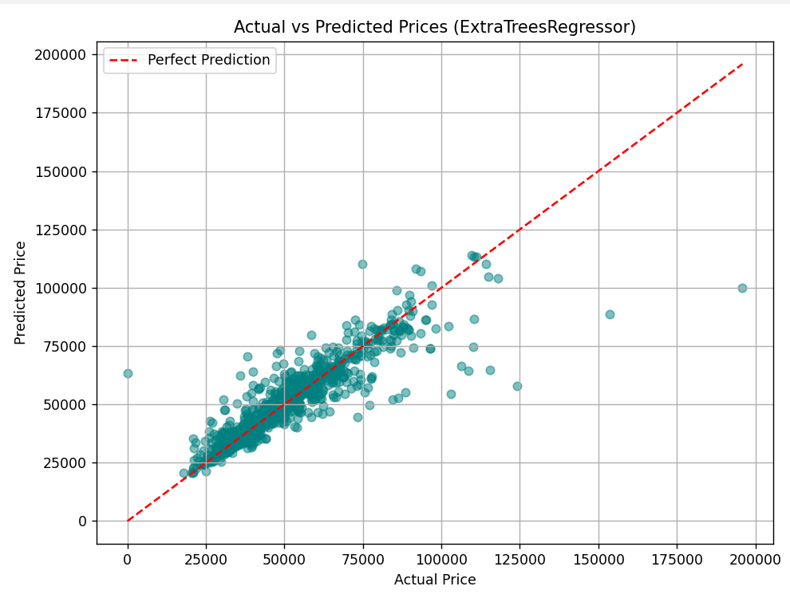

Visualization
Here is the link to dashboard published on Tableau.
https://public.tableau.com/views/Vehicleprice/Dashboard1?:language=en-US&:sid=&:redirect=auth&:display_count=n&:origin=viz_share_link
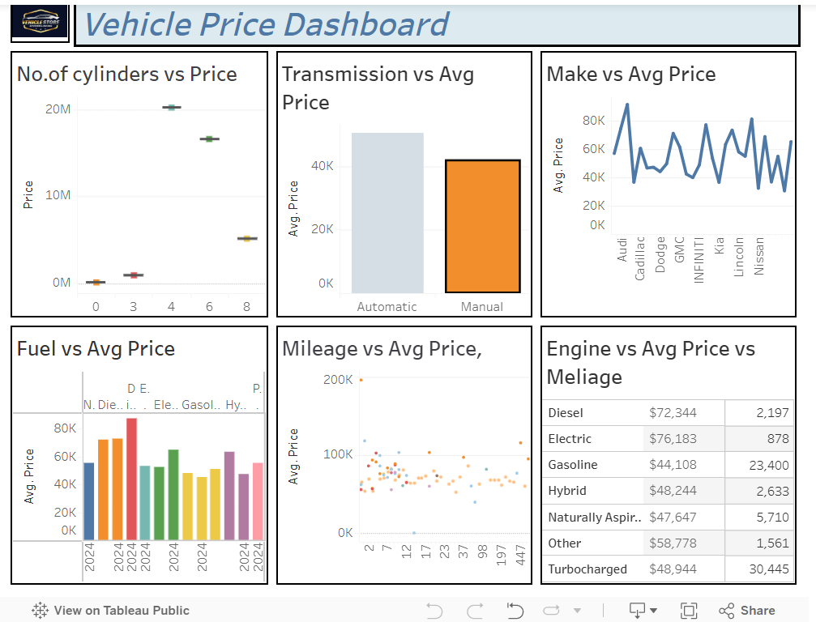

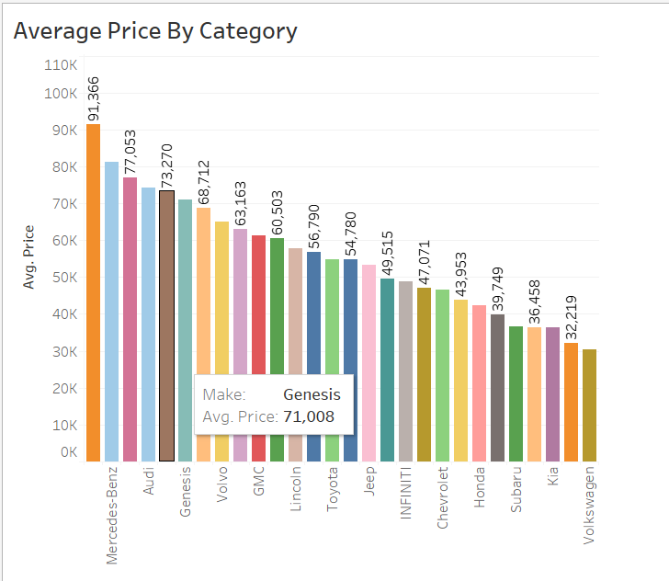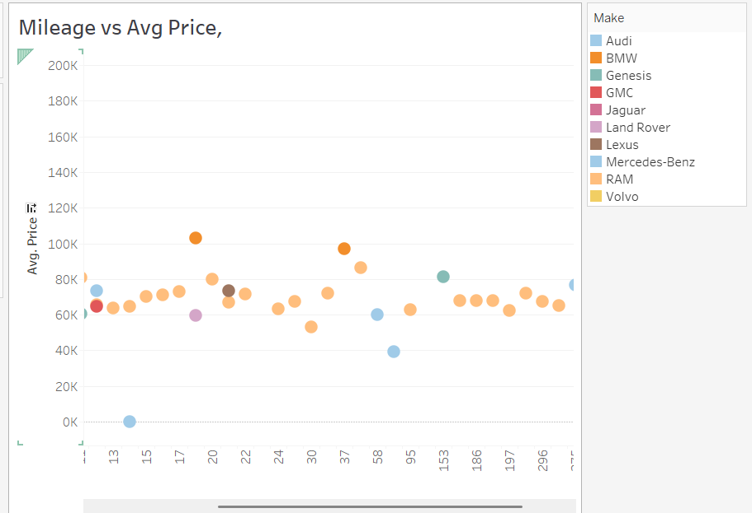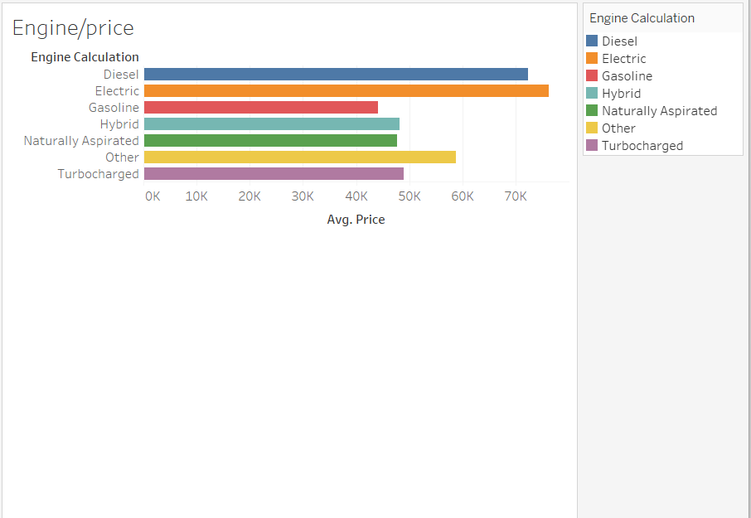

Separate code for Logistic Regression and Stacking
Logistic Regression model using scalars(MinMax Scalar,RobustScaler,StandardScaler)
import pandas as pd
import numpy as np
from sklearn.model_selection import train_test_split, KFold
from sklearn.preprocessing import LabelEncoder, StandardScaler, MinMaxScaler, RobustScaler
from sklearn.impute import SimpleImputer
from sklearn.linear_model import LogisticRegression
from sklearn.feature_selection import SelectKBest, chi2
from sklearn.metrics import accuracy_score, precision_score, recall_score, f1_score, confusion_matrix
import warnings
# Suppress warnings
warnings.filterwarnings("ignore")
# Load dataset
df = pd.read_csv('C:\\Users\\MONA\\Desktop\\Ramindar_Courses\\BCIT\\Advanced Data Analytics\\AdvDataAnal\\Vehicle Price.csv')
df = df.dropna(subset=['price']) # Drop rows with missing target
X = df.drop(columns=['price'])
y = df['price']
# Encode categorical variables
for col in X.select_dtypes(include=['object']).columns:
X[col] = LabelEncoder().fit_transform(X[col].astype(str))
# Impute missing values
imputer = SimpleImputer(strategy='mean')
X_imputed = pd.DataFrame(imputer.fit_transform(X), columns=X.columns)
# Feature selection
selector = SelectKBest(score_func=chi2, k=3)
selector.fit(X_imputed, y)
top_features = X_imputed.columns[selector.get_support()]
print("\nTop 3 selected features based on Chi-Square test:", list(top_features))
# Final feature set
X_final = X_imputed[top_features]
X_np = X_final.values
y_np = y.values
# Define scalers
scalers = {
'StandardScaler': StandardScaler(),
'MinMaxScaler': MinMaxScaler(),
'RobustScaler': RobustScaler()
}
# Apply K-Fold Cross-Validation for each scaler
for scaler_name, scaler in scalers.items():
print(f"\n========== Evaluating with {scaler_name} ==========")
kf = KFold(n_splits=5, shuffle=True, random_state=42)
accuracy_list, precision_list, recall_list, f1_list = [], [], [], []
fold = 1
for train_idx, test_idx in kf.split(X_np):
X_train, X_test = X_np[train_idx], X_np[test_idx]
y_train, y_test = y_np[train_idx], y_np[test_idx]
# Scale the features using the current scaler
X_train_scaled = scaler.fit_transform(X_train)
X_test_scaled = scaler.transform(X_test)
# Train model
model = LogisticRegression(fit_intercept=True, solver='liblinear', class_weight='balanced')
model.fit(X_train_scaled, y_train)
# Predict
y_pred = model.predict(X_test_scaled)
# Metrics
acc = accuracy_score(y_test, y_pred)
prec = precision_score(y_test, y_pred, average='macro', zero_division=0)
rec = recall_score(y_test, y_pred, average='macro', zero_division=0)
f1 = f1_score(y_test, y_pred, average='macro', zero_division=0)
# Store metrics
accuracy_list.append(acc)
precision_list.append(prec)
recall_list.append(rec)
f1_list.append(f1)
print(f"\nFold {fold}")
print("Accuracy :", acc)
print("Precision:", prec)
print("Recall :", rec)
print("F1 Score :", f1)
print("Confusion Matrix:\n", confusion_matrix(y_test, y_pred))
fold += 1
# Final summary for current scaler
print(f"\n--- Summary for {scaler_name} ---")
print(f"Average Accuracy : {np.mean(accuracy_list):.4f} (±{np.std(accuracy_list):.4f})")
print(f"Average Precision: {np.mean(precision_list):.4f} (±{np.std(precision_list):.4f})")
print(f"Average Recall : {np.mean(recall_list):.4f} (±{np.std(recall_list):.4f})")
print(f"Average F1 Score : {np.mean(f1_list):.4f} (±{np.std(f1_list):.4f})")
Outcome
All three scalers produced similar results, with slight variations depending on the data distribution in each fold.
- MinMaxScaler generally showed stable performance and slightly higher average F1-scores’
- RobustScaler was less affected by potential outliers but didn't consistently outperform the others.
- StandardScaler also performed well, if the feature distributions were close to normal.
Recommend MinMaxScaler with logistic regression on this dataset, given its slightly better and more consistent performance across folds.

Creating model using Stacking using Regression and Classification
import pandas as pd
import numpy as np
from sklearn.model_selection import train_test_split
from sklearn.preprocessing import LabelEncoder, StandardScaler
from sklearn.linear_model import LinearRegression, ElasticNet, LogisticRegression
from sklearn.tree import DecisionTreeRegressor, DecisionTreeClassifier
from sklearn.svm import SVR
from sklearn.ensemble import AdaBoostRegressor, RandomForestRegressor, ExtraTreesRegressor
from sklearn.ensemble import AdaBoostClassifier, RandomForestClassifier
from sklearn.metrics import mean_squared_error, precision_score, recall_score, f1_score, accuracy_score
# Load dataset
dataset = pd.read_csv('C:\\Users\\MONA\\Desktop\\Ramindar_Courses\\BCIT\\Advanced Data Analytics\\AdvDataAnal\\Vehicle Price.csv')
dataset = dataset.dropna(subset=['price'])
# REGRESSION SECTION
# Define regression features
regression_features = ['name', 'description', 'make', 'model', 'year', 'engine', 'cylinders',
'fuel', 'mileage', 'transmission', 'trim', 'body', 'doors',
'exterior_color', 'interior_color', 'drivetrain']
X_reg = dataset[regression_features].fillna('missing')
y_reg = dataset['price'].values
# Encode categorical columns
for col in X_reg.select_dtypes(include='object').columns:
le = LabelEncoder()
X_reg[col] = le.fit_transform(X_reg[col].astype(str))
X_reg = X_reg.values
# Define base regression models
def get_reg_models():
return [
ElasticNet(),
SVR(gamma='scale'),
DecisionTreeRegressor(),
AdaBoostRegressor(),
RandomForestRegressor(n_estimators=10),
ExtraTreesRegressor(n_estimators=10)
]
# Regression evaluation
def evaluate_reg_model(y_true, preds, model):
mse = mean_squared_error(y_true, preds)
rmse = round(np.sqrt(mse), 3)
print(f"RMSE: {rmse} - {model.__class__.__name__}")
# Train base and stacked regression models
def train_reg_models(X, y):
X_train, X_temp, y_train, y_temp = train_test_split(X, y, test_size=0.70, random_state=42)
X_test, X_val, y_test, y_val = train_test_split(X_temp, y_temp, test_size=0.50, random_state=42)
models = get_reg_models()
dfPred_val = pd.DataFrame()
for i, model in enumerate(models):
model.fit(X_train, y_train)
preds = model.predict(X_val)
dfPred_val[str(i)] = preds
stacked_model = LinearRegression()
stacked_model.fit(dfPred_val, y_val)
print("\n** Evaluate Base Regression Models **")
dfPred_test = pd.DataFrame()
for i, model in enumerate(models):
preds = model.predict(X_test)
dfPred_test[str(i)] = preds
evaluate_reg_model(y_test, preds, model)
stacked_preds = stacked_model.predict(dfPred_test)
print("\n** Evaluate Stacked Regression Model **")
evaluate_reg_model(y_test, stacked_preds, stacked_model)
# CLASSIFICATION SECTION
# Prepare classification data (binning price)
df_clf = dataset.copy()
df_clf['price_bin'] = pd.qcut(df_clf['price'], q=3, labels=[0, 1, 2])
y_clf = df_clf['price_bin']
# Drop columns and impute missing values
X_clf = df_clf.drop(columns=['price', 'name', 'price_bin'])
for col in X_clf.select_dtypes(include=['number']).columns:
X_clf[col] = X_clf[col].fillna(X_clf[col].median())
for col in X_clf.select_dtypes(include=['object']).columns:
X_clf[col] = X_clf[col].astype(str).fillna('missing')
for col in X_clf.columns:
if X_clf[col].dtype == 'object':
le = LabelEncoder()
X_clf[col] = le.fit_transform(X_clf[col].astype(str))
# Define base classification models
def get_clf_models():
return [
LogisticRegression(max_iter=1000),
DecisionTreeClassifier(),
AdaBoostClassifier(),
RandomForestClassifier(n_estimators=10)
]
# Classification evaluation
def evaluate_clf_model(y_true, preds, model):
precision = round(precision_score(y_true, preds, average='macro'), 2)
recall = round(recall_score(y_true, preds, average='macro'), 2)
f1 = round(f1_score(y_true, preds, average='macro'), 2)
accuracy = round(accuracy_score(y_true, preds), 2)
print(f"Precision: {precision} Recall: {recall} F1: {f1} Accuracy: {accuracy} - {model.__class__.__name__}")
# Train base and stacked classification models
def train_clf_models(X, y):
X_train, X_temp, y_train, y_temp = train_test_split(X, y, test_size=0.70, random_state=42)
X_test, X_val, y_test, y_val = train_test_split(X_temp, y_temp, test_size=0.50, random_state=42)
models = get_clf_models()
dfPred_val = pd.DataFrame()
for i, model in enumerate(models):
model.fit(X_train, y_train)
preds = model.predict(X_val)
dfPred_val[str(i)] = preds
stacked_model = LogisticRegression(max_iter=1000)
stacked_model.fit(dfPred_val, y_val)
print("\n** Evaluate Base Classification Models **")
dfPred_test = pd.DataFrame()
for i, model in enumerate(models):
preds = model.predict(X_test)
dfPred_test[str(i)] = preds
evaluate_clf_model(y_test, preds, model)
stacked_preds = stacked_model.predict(dfPred_test)
print("\n** Evaluate Stacked Classification Model **")
evaluate_clf_model(y_test, stacked_preds, stacked_model)
# Run both tasks
train_reg_models(X_reg, y_reg)
train_clf_models(X_clf, y_clf)

